Dr David C. Gaze
Biography

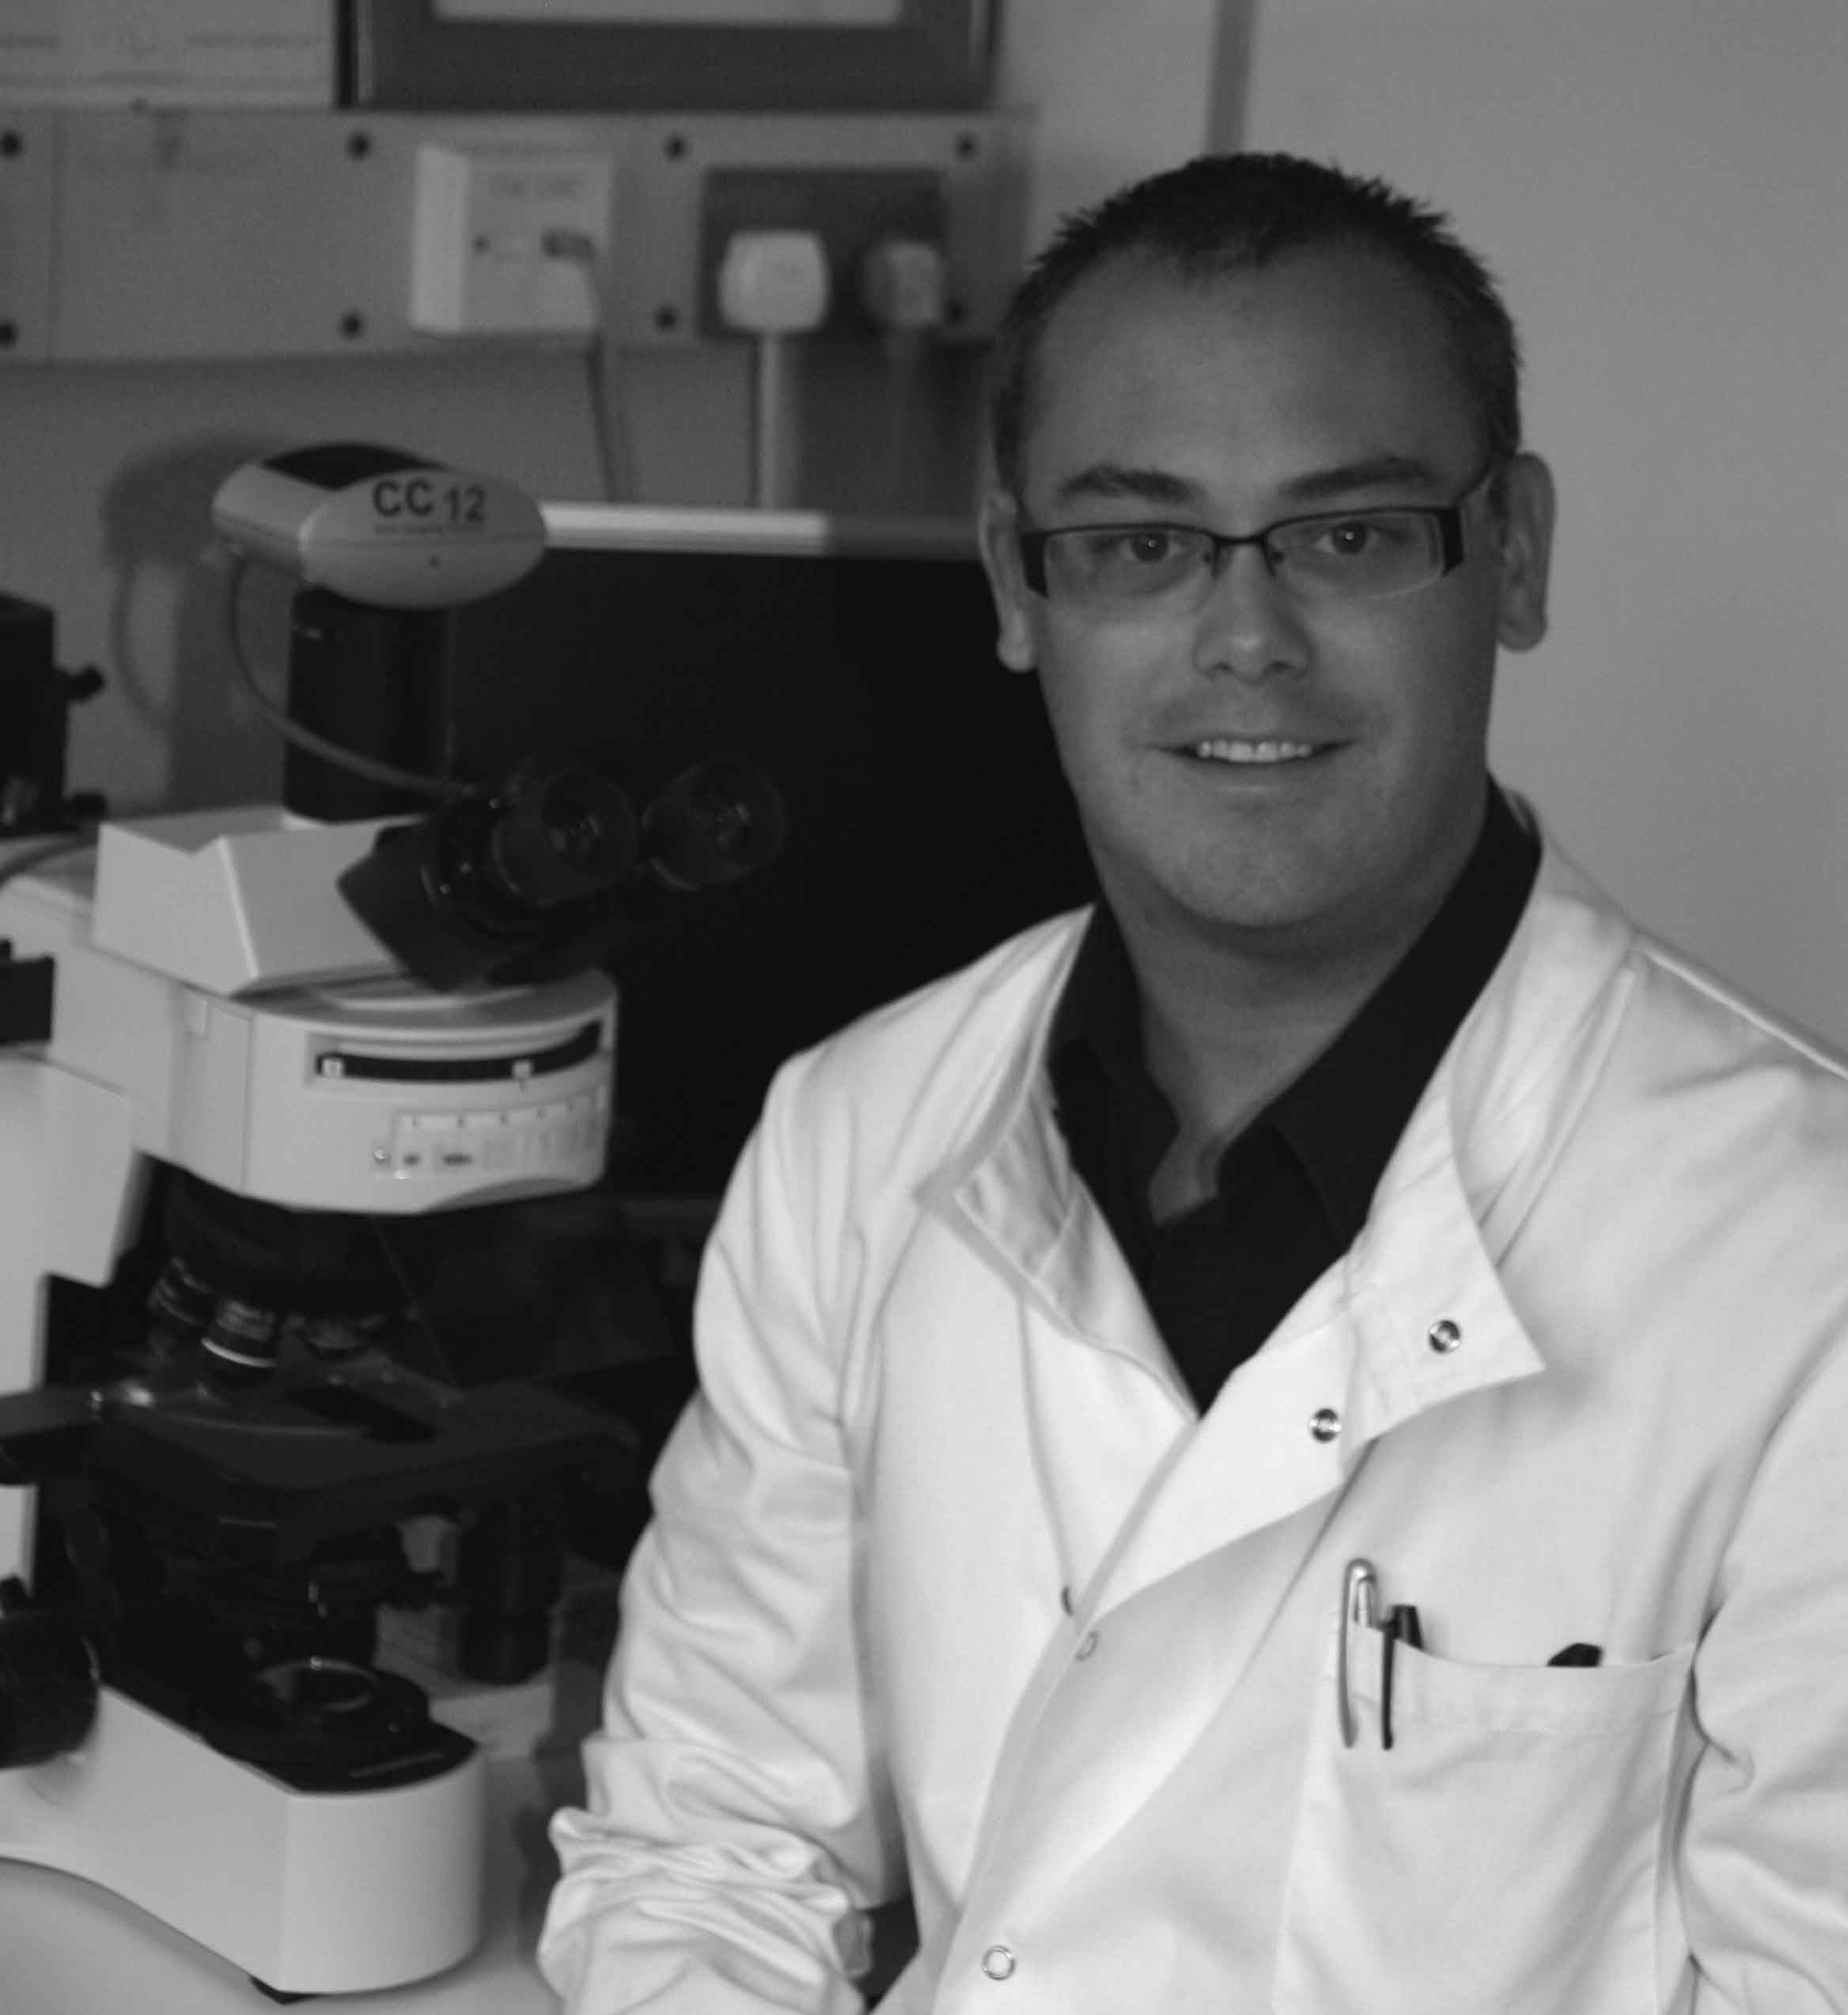
Dr David Gaze studied biochemistry at undergraduate and Masters level in West Yorkshire followed by a PhD in Clinical Biochemistry in London, United Kingdom. He is currently Lecturer in Clinical Biochemistry at the University of Westminster and Honorary Cardiac Research Scientist within the Department of Chemical Pathology, Clinical Blood Sciences at St George’s Hospital and Medical School, London.

He has authored and co-authored in excess of 150 peer reviewed papers and 200 abstracts, as well as presented at over 50 internationally invited conferences. He has contributed five book chapters to cardiovascular related textbooks as well as writing a textbook on cardiac troponin. He is a peer reviewer for 25 medical journals. He is the commissioning editor for review articles for the Annals of Clinical Biochemistry & Laboratory Medicine and is Co-editor-in-chief of Practical Laboratory Medicine.

His academic research interests are in the development and clinical utility of cardiac biomarkers for the detection of cardiovascular disease with a special interest in the cardiorenal population.

He is a member of the Royal Society of Medicine of London; The Association for Clinical Biochemistry, of which he chairs the Clinical Sciences Review Committee for the Annals of Clinical Biochemistry. He is also a member of the American Association of Clinical Chemistry; Institute of Biomedical Sciences; Institute of Biology; European Society of Pathology; The Pathological Society of Great Britain and Ireland and associate member of the Royal Institution of London.

Gaze and colleagues have won a number of awards including two distinguished Abstract awards from the National Academy of Clinical Biochemistry as well as Diploma for Oral Presentation regarding D-dimer, natriuretic peptide and cardiac troponin in dialysis patients presented at the 17th IFCC-FESCC European Congress of Clinical Chemistry and Laboratory Medicine and the 60th National congress of the Netherlands Society of Clinical Chemistry and Laboratory Medicine in Amsterdam in 2007.

